8. ReactJS-HOL

CountPeople.js

import React, { Component } from 'react';

class CountPeople extends Component {

constructor(props) {

super(props);

this.state = {

entryCount: 0,

exitCount: 0

};

}

updateEntry = () => {

this.setState((prevState) => ({

entryCount: prevState.entryCount + 1

}));

};

updateExit = () => {

this.setState((prevState) => ({

exitCount: prevState.exitCount + 1

}));

};

render() {

const { entryCount, exitCount } = this.state;

const buttonStyle = {

backgroundColor: 'lightgreen',

padding: '5px 10px',

border: '1px solid green',

marginRight: '10px',

cursor: 'pointer'

};

const boxStyle = {

display: 'inline-block',

margin: '20px',

textAlign: 'center'

};

return (

<div style={{ textAlign: 'center', marginTop: '50px' }}>

<div style={boxStyle}>

<button style={buttonStyle} onClick={this.updateEntry}>Login</button>

<span>{entryCount} People Entered!!!</span>

</div>

<div style={boxStyle}>

<button style={buttonStyle} onClick={this.updateExit}>Exit</button>

<span>{exitCount} People Left!!!</span>

</div>

</div>

);

}

}

export default CountPeople;

App.js

import React from 'react';

import CountPeople from './CountPeople';

function App() {

return (

<div>

<CountPeople />

</div>

);

}

export default App;

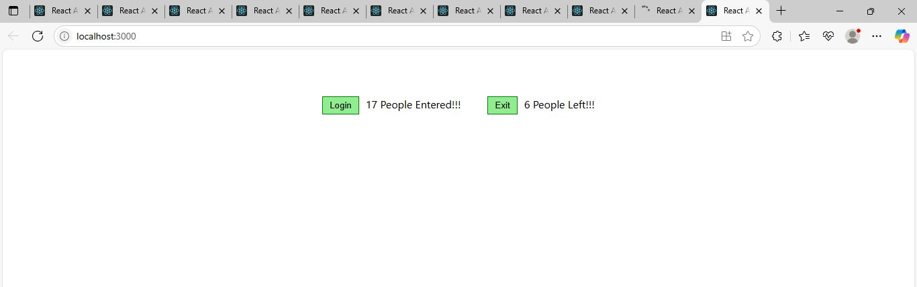

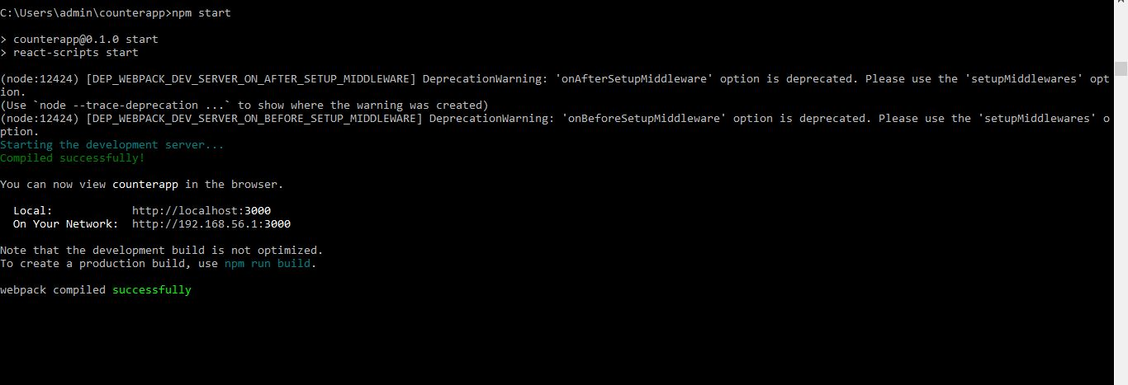

What is React State?
In React, state refers to a built-in object that holds dynamic data for a component. State enables a component to keep track of information that can change over time, and when it does, the component re-renders to reflect those changes on the screen.

Why is State Important?
- React components are reactive—they update automatically when their state changes.
- State is used to control user interactions, form inputs, counters, dynamic content, etc.
- It allows for interactive UIs without manual DOM manipulation.

Key Points:
- State is local to a component.
- State is created using:
  - this.state in class components
  - useState() hook in functional components
- State should never be modified directly. Use setState() in class components and the setter function from useState() in functional components.

